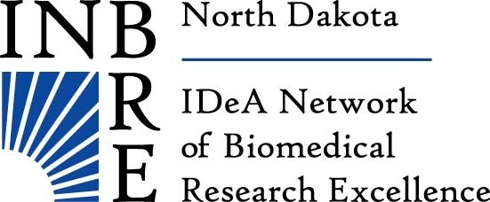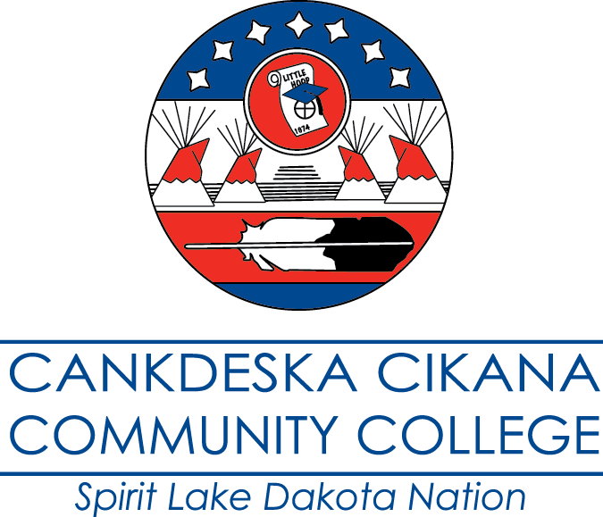

8:00-9:00 am Registration, refreshments, and   
 poster set up

9:00-9:15 am Welcoming remarks and prayer

9:15-9:30 am Cynthia Lindquist Ph.D.

Research at Tribal Colleges

9:30-10:30 am Dennis White

Title “The Beauty of Mathematics All Around Us”

Keynote Speaker

10:30-11:00 am Break

11:00-11:30 am Krystal Tsosie, MS Turtle Mountain Community College

Title “To be determined”

11:30 am Dennis White

Invocation

Lunch will be served afterwards

1:00-3:00 pm Poster Session – (Gymnasium)

## AGENDA

# 6th Annual Tribal College Research Symposium

### March 27th, 2018

### 8:00 am-3:00 pm

### CCCC Amphitheatre